Continue working on this

## Echinoculture research and practices

The primary driver of sea urchin market value is gonad quality (Teck et al., 2018). Gonad quality is determined by a number of factors including colour, texture, taste and gonad somatic index (GSI) (Cyrus et al., 2015). Quality of the sea urchin fishery is highly variable and dependent on the reproductive state of the organism (Teck et al., 2018). The price differential paid for sea urchin roe across varying reproductive stages can be substantial, with early stages (prior to spawning) being preferred what stage is preferred and why? (Teck et al., 2018)

However, good health is required for good gonad production. The health and well-being of sea urchins is also determined by a number of factors incl. …

* (What are factors that have affected gonad quality/growth rate/feeding rate for other species?)

Live sea urchin products are in the highest demand. Japan imported ~ 11 000 tonnes of live sea urchin in 2016 valued at 183 million US dollars, a six-fold increase in volume and nine-fold increase in value since 1975 (Sonu, 2017). (processed) Sea urchin product (live and processed) prices are dependent on a number of factors including appearance (color, quality), origin (species, region of harvest), palatability (flavour, texture), demand, distribution, form and processing(Stefánsson et al., 2017) .

Although quality of roe is the most important factor in determining prices, total supply (domestic and imported roe) is also significant (Sonu, 2017).

* Has anyone done anything similar? What did they find?

The sea urchin industry is also associated with aquaculture, with efforts being made to sustainably cultivate sea urchins for commercial purposes (Rubilar & Cardozo, 2021). In the USA, sea urchin aquaculture is being considered in several states, including California, Oregon, Washington, Maine, Massachusetts, and New Hampshire (Nelson et al., 2010).

- Do they have other uses, besides for human consumption?

In addition to their culinary value, sea urchins are commercially exploited for their gonads, which are used for quality roe production, naphthoquinone pigments, and drug discovery (Rubilar & Cardozo, 2021). Furthermore, sea urchins are used as a feed supplement or total replacement for a commercial shrimp diet, and their feces have been evaluated as a food source for small sea cucumbers in integrated multi-trophic aquaculture systems (Jensen et al., 2018; Yu et al., 2023). Sea urchin gametes, embryos and larvae have also been used for fast, low-cost and reliable screening of toxic substances, and for detailed studies of their mechanism of action (Micael et al., 2009).

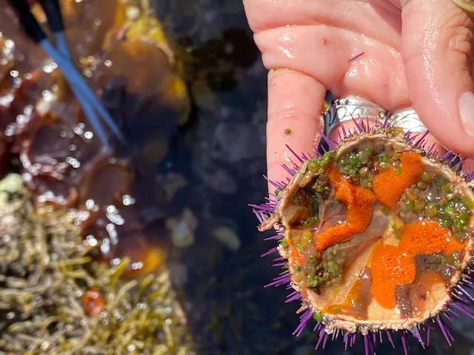

Figure 4: Image of Cape urchin, *P. angulosus*, harvested by Veld and Sea for consumption